DMG Media Case study : Production process
http://dmgmediapresents.co.uk/nightly-miracle/
stage | image | What is involved
 | 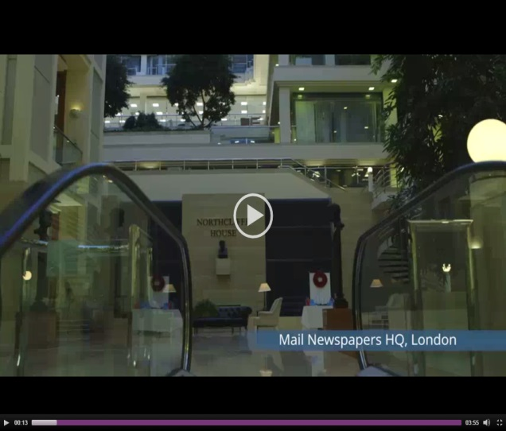 | The HQ is in Northcliffe this is where the daily mail and the mail on Sunday
 | 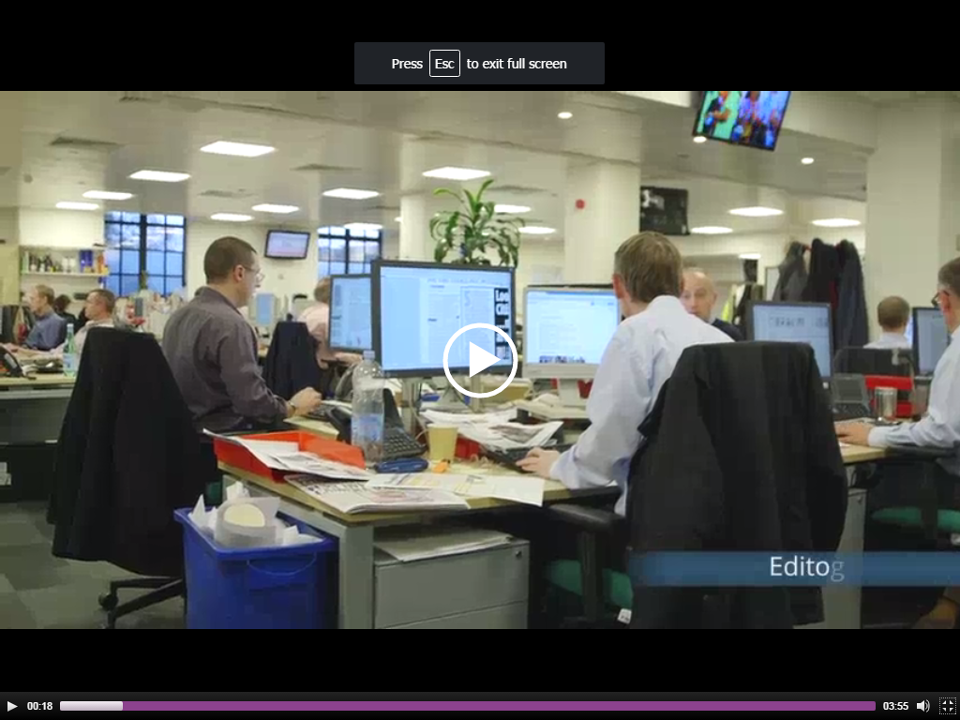  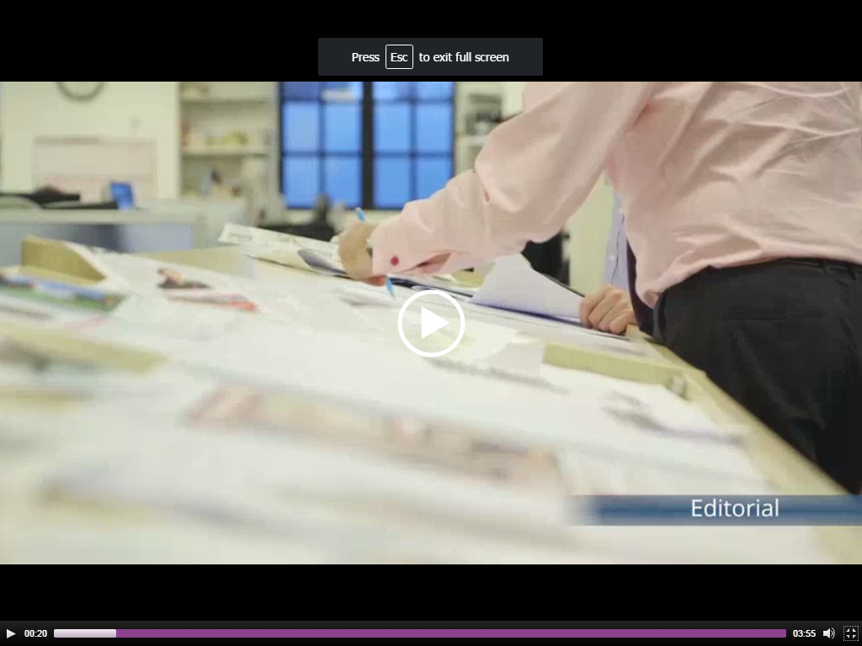 | The editors not only design the newspaper but they also check for mistakes as well. Then after this the head editor does the final check to finalise it.  They also mark the paper suggesting changes and improvements.
 | 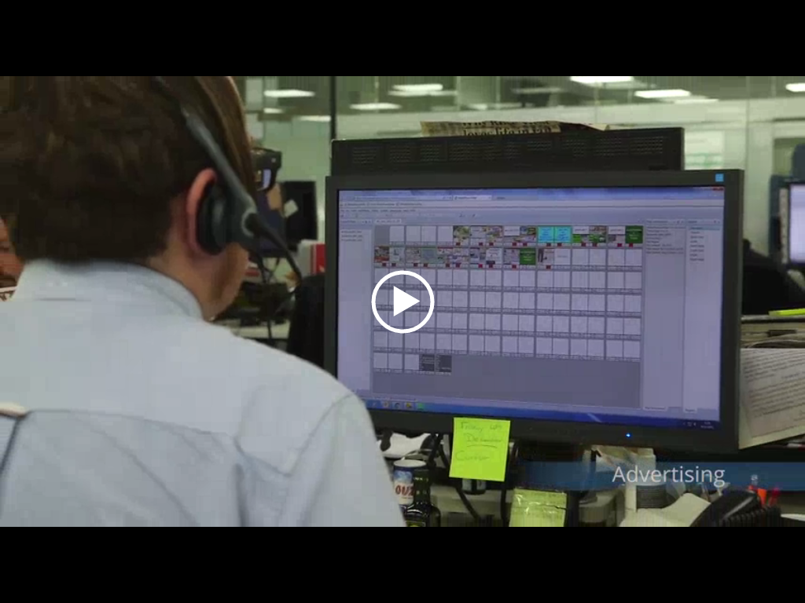 | This shows the pages being checked as they are completed. This would be done by editors.
 | 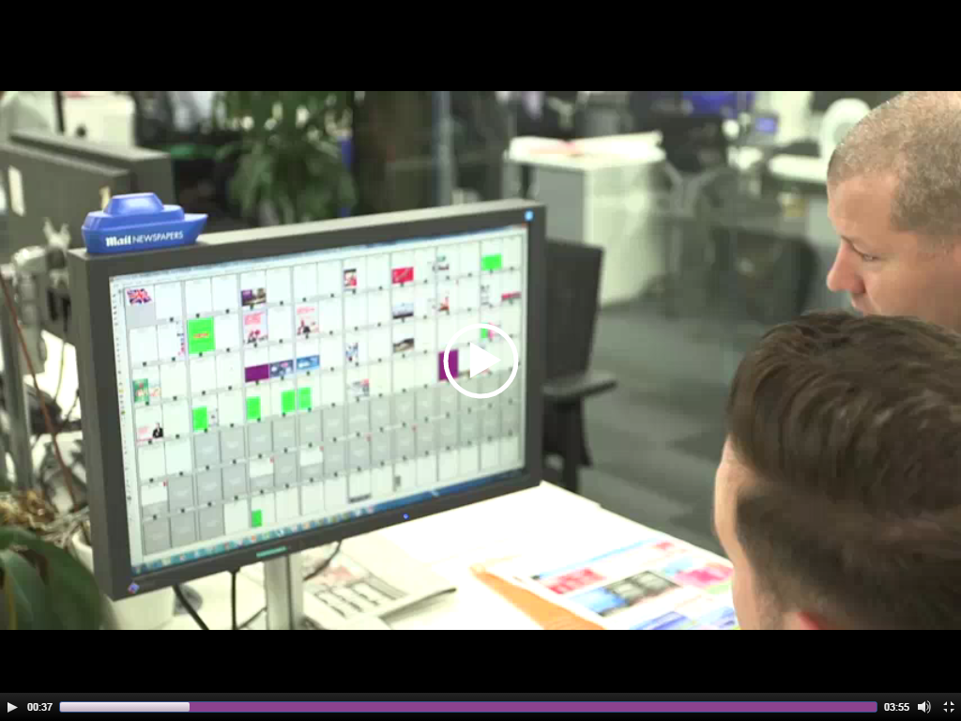 | The next floor up is for advertising and planning where the adverts will go on the newspaper. The newspaper makes money by having people selling spaces on the page for adverts.
 | 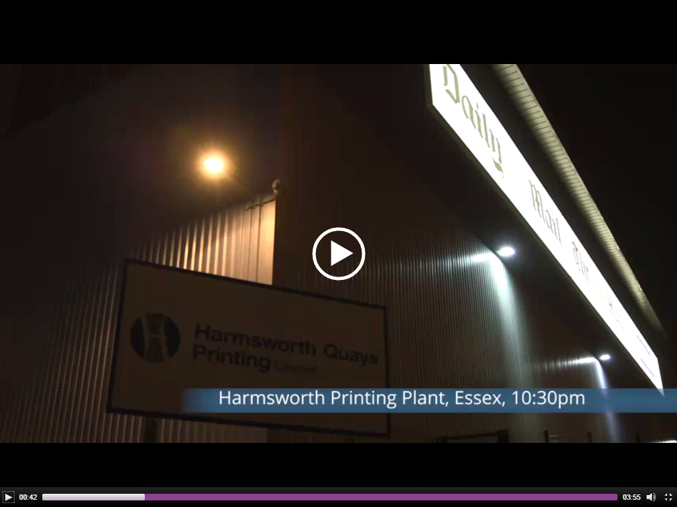 | At around 10:30 they start the printing process. The first thing they do is send the copy to the computer rooms to make sure they are in the right order
 | 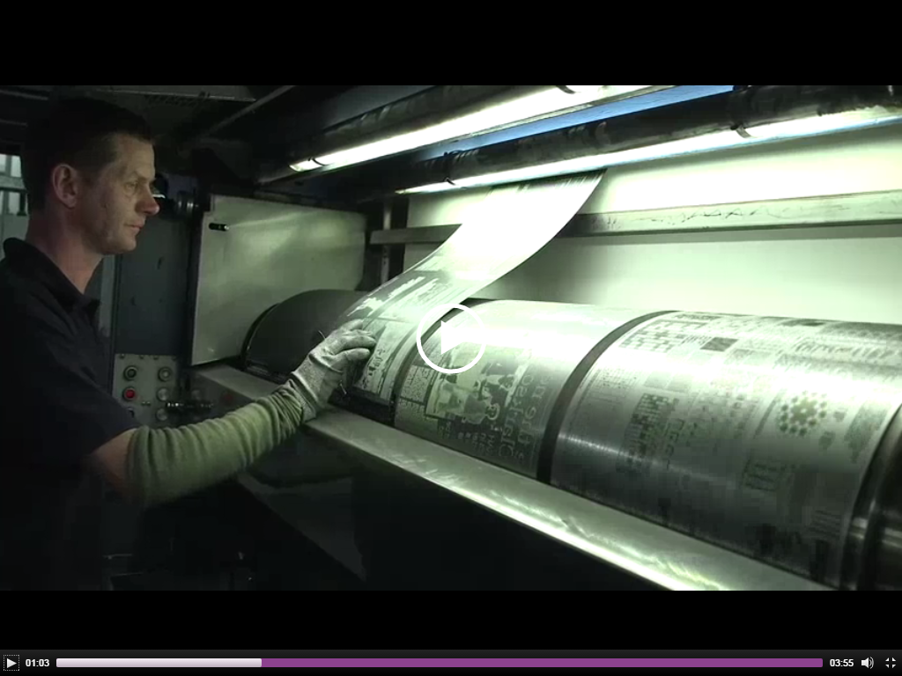 | Engravings are laser cut into sheet metal to act as a stamp to print multiple copies of the same sheet
 | 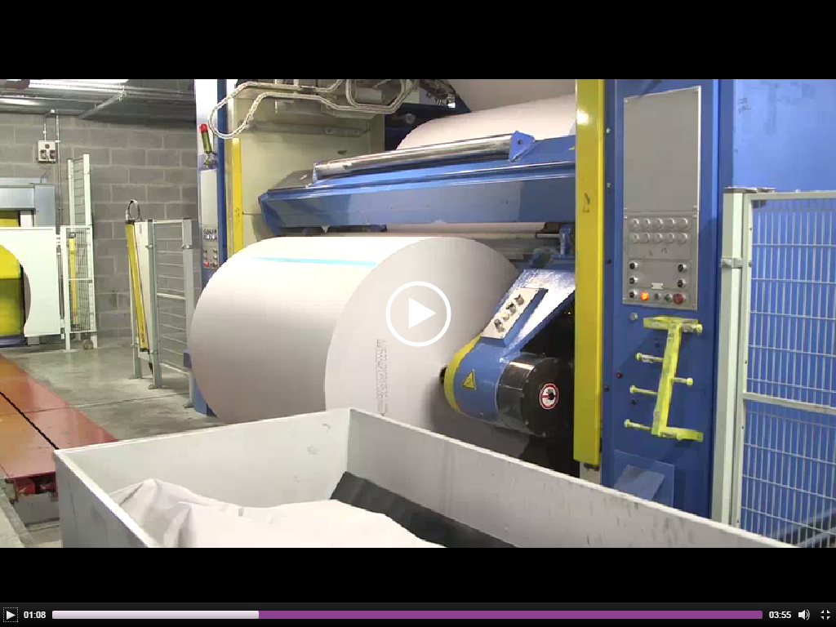 | This is the huge role of paper the newspaper is printed onto.
 | 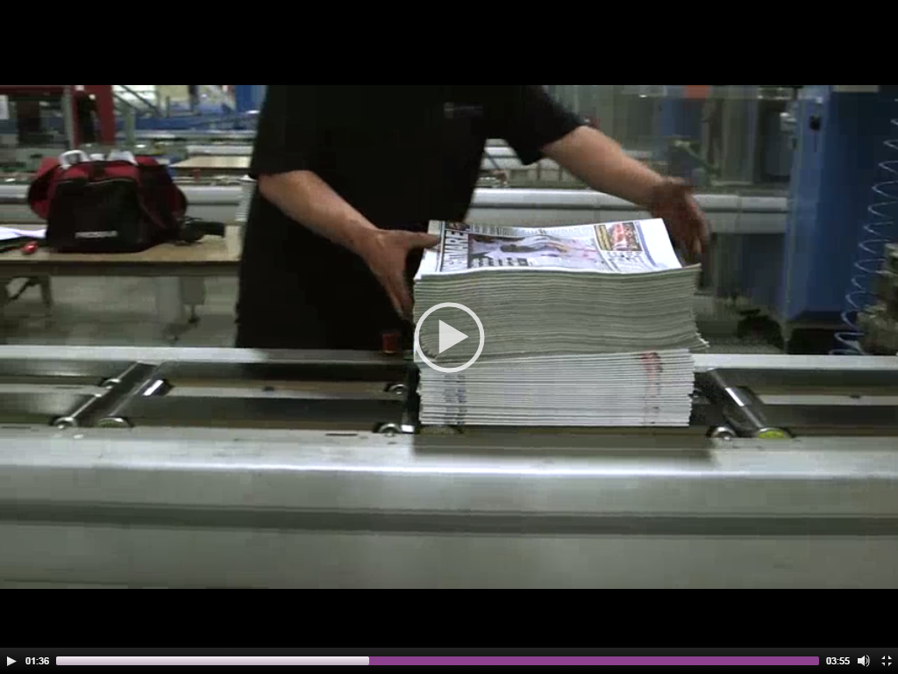 | This man’s job is to just straighten the paper
 | 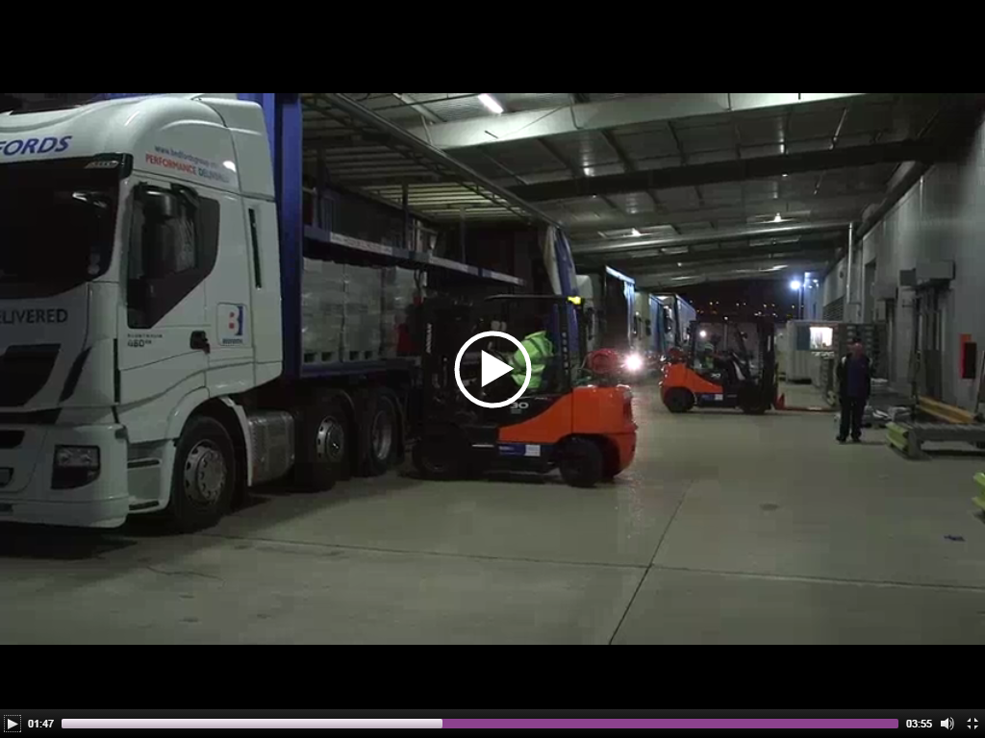 | They load the papers onto lorries to distribute the papers to a distribution centre to be organised for different places, they deliver them to the different places using a van
 | 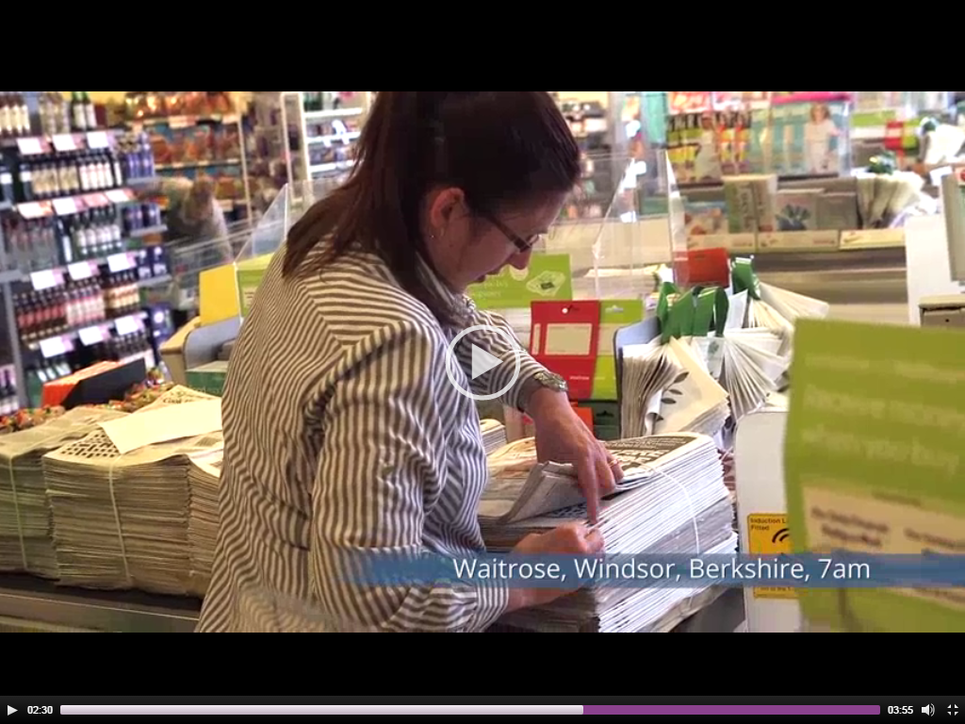 | Trucks deliver papers to the retailers.
 | 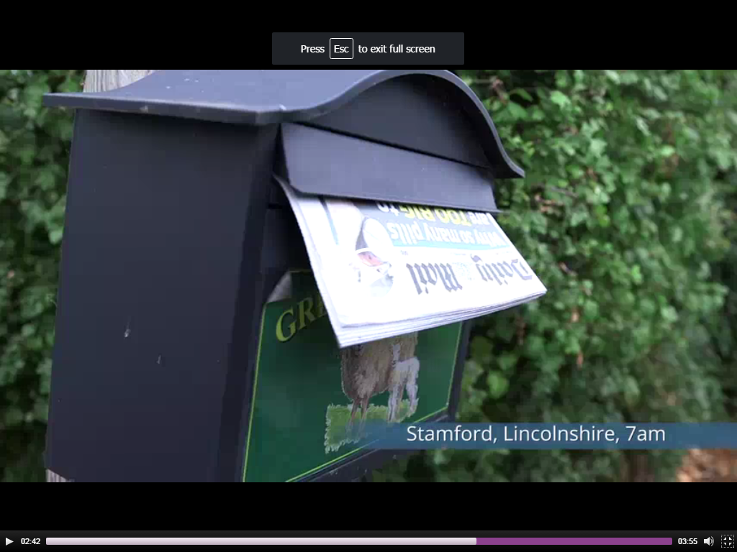 | Its delivered to people personally by paperboy.
 | 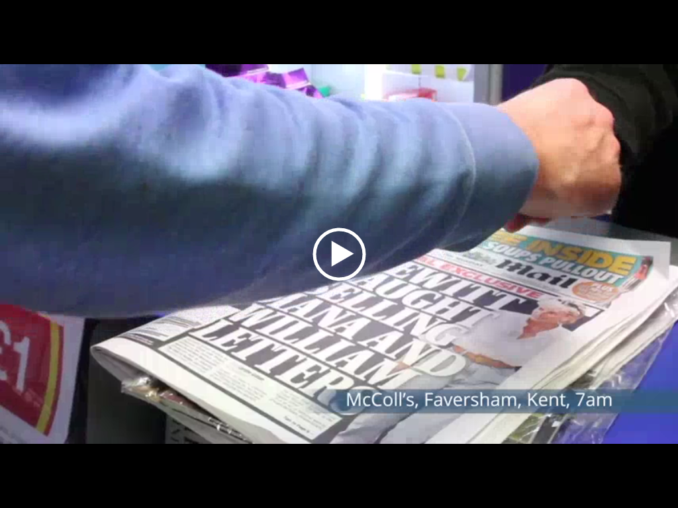 | The company also delivers to parts of Scotland.

- There are 20 copies printed per second per press
- 50,500 retailers are served each day
- 165,000 miles are driven each day
- 2.4 million papers are made each day
- The company has 82 wholesale site

